Title of full paper
First author, M.Sc.¹ and Corresponding author, Ph.D.^{1,2*}
¹Affiliation 1 and address, 90110, Thailand
² Affiliation 2 and address, 90110, Thailand

*Corresponding author: name of corresponding author, Ph.D. Affiliation and address. E-mail: xxxx@xx.ac.th
Abstract:
Objective: Many medical biosensors have been widely developed for use in clinical diagnosis as point-of-care testing. However, most of them still suffer from inaccurate results, caused by the lack of biosensor stability under variable pH of biofluid samples; such as urine. Hence, the instability in pH variation is one of the key challenges for electrochemical biosensors. In this study, the development of a gold nanoparticles-Prussian blue (AuNPs-PB) based screen-printed electrode was investigated for its performance, in terms of electrochemical stability within various pH solutions.
Material and Methods: The AuNPs-PB modified screen-printed gold electrode (SPAuE) was developed and optimized using an electrodeposition technique and cyclic voltammetry, respectively. As compared to PB modified SPAuE, the signal response of cyclic voltammograms at AuNPs-PB modified SPAuE was examined in a phosphate buffer solution with different pH values. The electrochemical stability of the modified SPAuE was considered on the invariability of the Prussian blue (PB) redox current in different pH solutions.
Results: The result revealed that stable current signals of PB in different pH solutions at the AuNPs-PB modified SPAuE showed good electrochemical stability, with a relative standard deviation (RSD) of oxidation and reduction peak currents being 1.03% and 1.11%, respectively. The signal stability results exhibited over two and five times when compared to those of the PB modified SPAuE (without gold nanoparticles), which were 2.41% and 5.61% RSD, respectively.
Conclusion: The AuNPs-PB modified SPAuE provides a potential, alternative tool for the enhancement of electrochemical stability for use in medical biosensor applications.
Keywords: Electrochemical stability, Gold nanoparticles, Biosensor, pH effect, Point-of-care testing

Introduction
Biosensors are analytical devices that operate based on their biological receptors being in direct contact with transducers.¹ They have played an important role in medical diagnosis and patient monitoring, for providing quantitative or quasi-quantitative information to indicate a specific disease state or other physiological states in patients. This makes biosensors well suited to be applicable for a variety of diagnostic devices. Especially, electrochemical biosensors, which have gained great attention in the development of a compact analytical device for Point-of-Care testing.²
To the best of our knowledge, this is the first time that the stability of AuNPs-PB modified screen-printed gold electrodes (SPAuEs) has been investigated under different pH buffer solutions. Herein, the purpose of this work was to develop a PB in combination with AuNPs modified on SPAuEs, for the improvement of electrochemical stability in pH variations for use in clinical applications. A AuNPs-PB modified SPAuE was developed by applying electrodeposition. Experimental parameters involved in PB electrodeposition; including, concentrations of K₃[Fe(CN)₆] and FeCl₃ as well as a number of scan cycles during the electrodeposition were optimized. The morphologies and electrochemical behaviors of both PB modified SPAuEs, with and without AuNPs, were characterized. Finally, the electrochemical stability of the AuNPs-PB film modified with SPAuE in different pH solutions was investigated through PB redox signals obtained from cyclic voltammetry.

Materials and Methods
Materials
Potassium ferricyanide (K₃[Fe(CN)₆], Sigma-Aldrich, Germany), iron (III) chloride (FeCl₃, Sigma-Aldrich, Germany), potassium chloride (KCl, Ajax Finechem, USA), hydrochloric acid (HCl, RCI Labscan, Thailand), and Hydrogen tetrachloroaurate(III) hydrate (HAuCl₄, Acros Organics™, Belgium) were used as received. Sodium dihydrogen phosphate monohydrate (NaH₂PO₄ · H₂O) and di-sodium hydrogen phosphate dihydrate (Na₂HPO₄ · 2 H₂O), substances used to prepare a phosphate buffer, were obtained from Merck, Germany. All aqueous solutions were prepared using a Milli-Q purified water (resistivity ≥18 MΩ cm, Millipore).
All electrochemical methods were performed using a potentiostat μAutolab PGSTAT204, with the computer-controlled by NOVA 2.1.4 software. Screen-printed gold electrodes (SPAuEs, DRP-250AT) were from Metrohm, the Netherlands. Scanning electron microscope images were achieved by a Tabletop SEM (TM3030Plus, Hitachi).

AuNPs-PB electrodeposition
Initially, the electrodeposition of the PB film on a gold electrode surface was conducted in the same manner as the study of Haji-Hashemi et al., 2018.⁷ Briefly, the PB film was electrochemically formed by immersing it in an aqueous solution containing 100 mmol L⁻¹ KCl, 10 mmol L⁻¹ HCl, K₃[Fe(CN)₆], and FeCl₃, at different concentrations. The cyclic voltammetry was performed with a potential range of -0.20 to +1.0 V, at a scan rate of 50 mV s⁻¹. Different concentrations of K₃[Fe(CN)₆] and FeCl₃ as well as the number of electrodeposited scan cycles were optimized. As seen in Figure 1, AuNPs-PB film on a SPAuE (AuNPs-PB/SPAuE) was prepared in a solution containing the optimal concentrations of K₃[Fe(CN)₆], and FeCl₃; 100.0 mmol L⁻¹ KCl, 10.0 mmol L⁻¹ HCl, and 0.50 mmol L⁻¹ HAuCl₄ (a chemical compound containing AuNPs), using cyclic voltammetric scanning between −0.20 and +1.0 V for 20 cycles, at a scan rate of 50 mV s⁻¹. After this step, the AuNPs-PB/SPAuE was rinsed with de-ionized water and dried with nitrogen gas. For comparison, a PB/SPAuE was fabricated using the same methods; but without the addition of HAuCl₄.

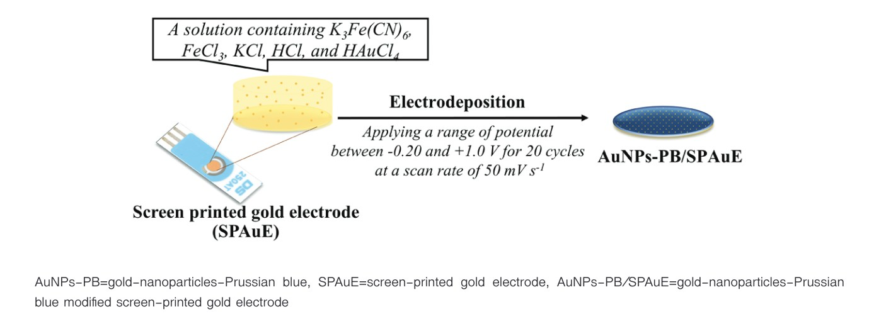
Figure 1 Schematic illustration showing the electrodeposition of the AuNPs-PB film on the SPAuE surface.
Results
Optimization study
The concentrations of K₃[Fe(CN)₆], FeCl₃ and the number of electrodeposited scan cycles were studied. After PB electrodeposition, the obtained cyclic voltammograms showed the redox peak currents of PB; as seen in Figure 2. At 0.25 mmol L⁻¹ K₃[Fe(CN)₆] and 0.25 mmol L⁻¹ FeCl₃, the current response was higher when increasing the number of scans. Cyclic voltammograms at the conditions of 0.50 mmol L⁻¹ and 1.0 mmol L⁻¹ of both K₃[Fe(CN)₆] and FeCl₃ showed similar PB signals, for which the maximum current response was found at 20 scans. At 10 scans, the current signal had the lowest response; whereas, it can be observed that a decrease in current response and wide displacement between the oxidation and reduction peak potentials occurred at 30 scans.

Surface morphologies
The surface morphologies of the PB film (Figure 2a) and the AuNPs-PB film (Figure 2b) modified on SPAuE were investigated using SEM. The PB film showed small sphere-like particles homogeneously dispersed on the SPAuE surface; whereas, the AuNPs-PB film was rough and exhibited many nanoparticles embedded within the PB film. Table 1 shows Values of Ipa, Ipc, and Ipc/Ipa ratio obtained from cyclic voltammograms of the PB/SPAuE and the AuNPs-PB/SPAuE.
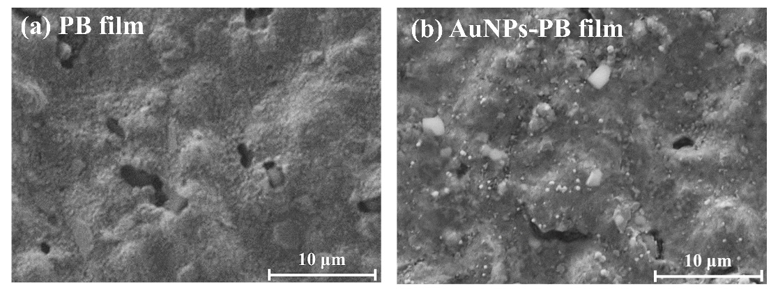
Figure 2 SEM images of the modified SPAuE: (a)PB/SPAuE, and (b)AuNPs-PB/SPAuE.

Table 1 Values of I_{pa}, I_{pc}, and I_{pc}/I_{pa} ratio obtained from cyclic voltammograms of the PB/SPAuE and the AuNPs-PB/SPAuE
Electrodes | I_{pa} (μA) | I_{pc} (μA) | I_{pc}/I_{pa} ratio
PB/SPAuE 1 | 110.17 | −72.96 | 0.66
AuNPs-PB/SPAuE 2 | 166.36 | −112.42 | 0.67

Discussions
In this study, it was demonstrated that the AuNPs-PB film deposited on SPAuE could contribute to the improvement of the electrochemical performance of the PB signal. Initially, the optimization study was carried out to determine the optimal conditions in the process of PB electrodeposition. As per the results showed, at 0.25 mmol L⁻¹ K₃[Fe(CN)₆] and 0.25 mmol L⁻¹ FeCl₃, the current response was higher when increasing the number of scans. This is due to the larger electroactive site of PB on the gold electrode surface. Moreover, it was noted that two reduction peaks were observed for every scan. Similarly, the couple reduction peaks at 0.50 mM K₃[Fe(CN)₆] and 0.50 mmol L⁻¹ FeCl₃ as well as 1.0 mM K₃[Fe(CN)₆] and 1.0 mmol L⁻¹ FeCl₃ were also found at 10 cycles. The electrochemical behavior, showing at a peak at approximately 0.15 V, is most likely massive precipitation of PB occurring in the process of the reduction of Fe³⁺ to Fe²⁺, as was discussed in Isfahani et al., 2019.²² The mentioned mechanism is probably due to the reaction of the (Fe(III) [Fe(III)(CN)₆]) complex with the conductive material; as shown in reaction (2) and (3). However, the behavior for the concentrations of 0.50 and 1.0 mmol L⁻¹ at 20 and 30 scan cycles disappeared.

Conclusion
This study developed an AuNPs-PB modified SPAuE, using the electrodeposition technique. The optimal condition at a concentration of 0.50 mmol L⁻¹ K₃[Fe(CN)₆] and FeCl₃, and the number of scans at 20 cycles was applied to fabricate the AuNPs-PB film during the electrodeposition process. The performance of the AuNPs-PB/SPAuE was evaluated in comparison with a PB modified SPAuE without AuNPs. The AuNPs-PB/SPAuE offers great potential for the stability of PB-based electrochemical biosensors as an attractive alternative for use in medical biosensors.

Acknowledgments
We gratefully acknowledged the XXXX for the financial support. We would also like to thank xxxxxxxx for editing the English of the manuscript.

Conflict of interest
There are no potential conflicts of interest to declare.
References
1. Thévenot DR, Toth K, Durst RA, Wilson GS. Electrochemical biosensors: recommended definitions and classification. Biosens Bioelectron 2001;16:121–31.
2. Yang A, Yan F. Flexible electrochemical biosensors for health monitoring. ACS Appl Electron Mater 2021;3:53–67.
3. Clarkson MR, Magee CN, Brenner BM. Laboratory assessment of kidney disease. In: pocket companion to Brenner and Rector’s the kidney (eighth edition) 2011. p. 21–41.
4. Wu X, Cao M, Hu C, He X. Sonochemical synthesis of Prussian blue nanocubes from a single-source precursor. Cryst Growth Des 2006;6:26–8.
5. Zhang M, Hou C, Halder A, Ulstrup J, Chi Q. Interlocked graphene–Prussian blue hybrid composites enable multifunctional electrochemical applications. Biosens Bioelectron 2017;89:570–7.
6. Keihan AH, Ramezani Karimi R, Sajjadi S. Wide dynamic range and ultrasensitive detection of hydrogen peroxide based on beneficial role of gold nanoparticles on the electrochemical properties of prussian blue. J Electroanal Chem 2020;862:114001.
7. Karyakin AA. Prussian blue and its analogues: electrochemistry and analytical applications. Electroanalysis 2001;13:831–5.

